TV3D SDK version 6.5
ModelView Introduction
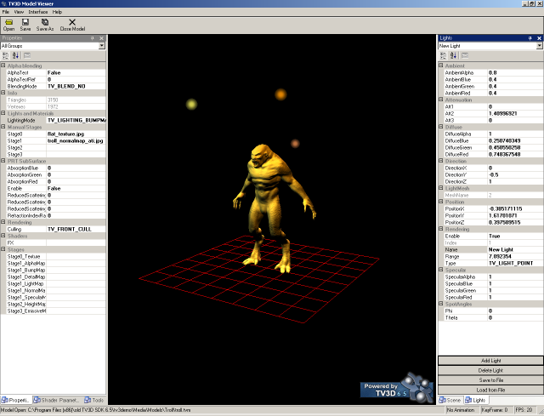
Copyright 2007 Truevision3D, LLC

Table of Contents

- Introduction

- Basic UI Introduction

- Scene Properties

- Scene Lights

- Model Properties and Shaders

- Global, Mesh and Actor Tools
  - Flip Normalmap Tangent
  - Flip Normalmap Binormal to DX
  - Save Stage1 Texture
  - Apply Default Material
  - Compute Normals
  - Remove UV
  - Weld Mesh
  - Generate Normalmap
  - Generate PRT
  - Animation Ranges
  - Control Morph Weight
  - Add Morph Targets

- Notes and known Bugs

1. Introduction
ModelView is a tool included in the TV3D SDK 6.5. The purpose of this tool is to let artists and users process models and graphics before putting them in-game. Model formats supported are TVM, TVA and X. ModelView can be used for generating normalmaps, based on high definition models, generate PRT data and apply shaders to the models. Several basic features for model processing are included as well; applying textures on different stages, calculating normals, flipping normals, welding meshes, playing animated models and playing with scene properties. This tool is crucial for the artistic pipeline.

2. Basic UI Introduction
When you open MV for the first time it will look something like this:

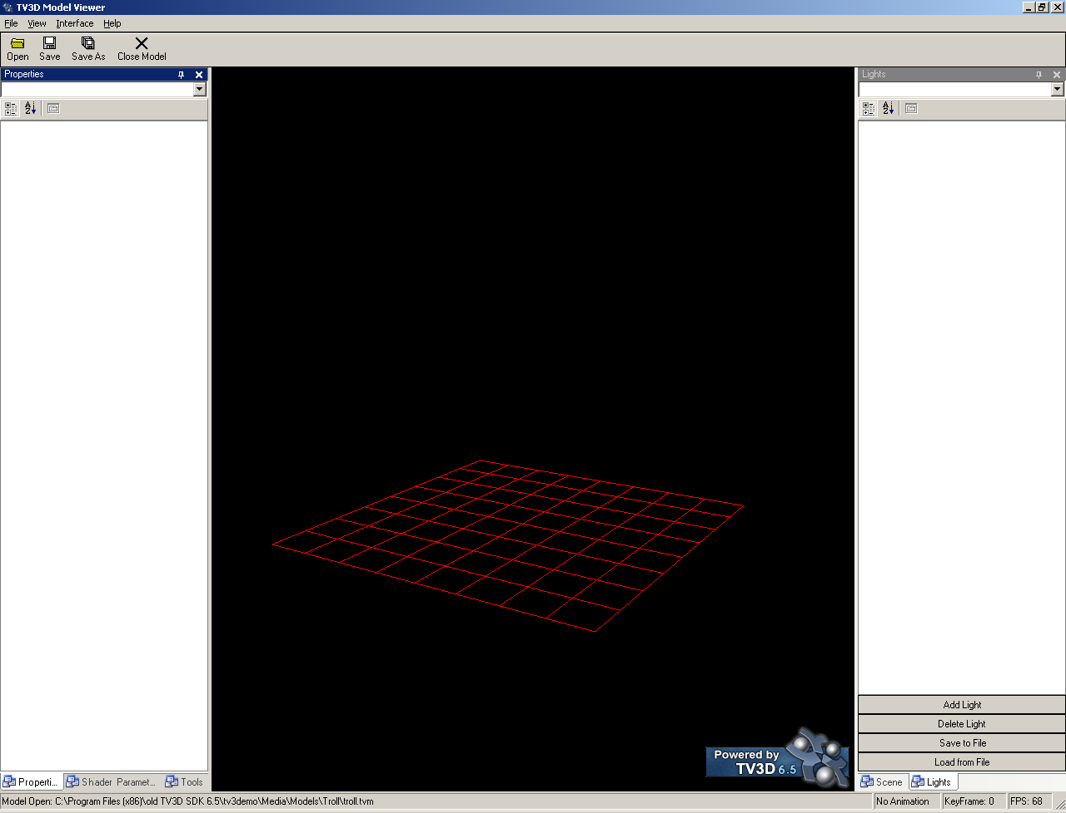
On the left side you have mesh properties, shader parameters and global tools. This is where you modify the properties and parameters of your object. In the middle you have what is called the MV scene, this is the area where your model is rendered. On the right side you have properties and parameters for the MV scene. This includes adding and removing lights and playing with the properties of the lights. You can also add scene effects such as glow, motion blur and depth of field.

You use your Mouse Button 1 to rotate the camera around the model, holding Mouse Button 2 will let you zoom in and out. When you are ready to Open your model up just press the “Open” button and browse for it.
3. Scene Properties
When you open your model it will be placed in the MV scene on the grid (or around it depending on your models local position). From this point you can now start to process your model. Lets first learn how the scene properties work.

In the scene properties dock you can change background color of the scene, set depth of field parameters, enable glow, set glow properties, enable motion blur, change the rendering mode, change depth buffer, display bone names (for animated/rigged models), enable/disable the grid, display skeleton, enable specular lighting in the scene, play with the mip map precision and set the texture filter. You can also change the View Frustum parameters.

Lets enable glow and disable the grid by double clicking on the values in the scene properties dock. You should have a result that looks something like this:

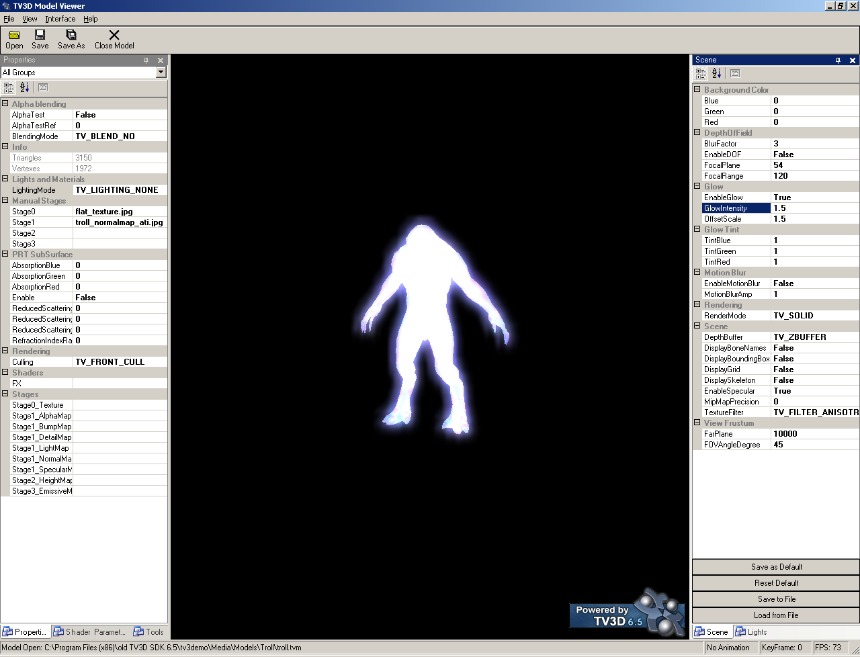
If you like you can save the scene properties to an scene properties file and load it on different models to see how they look in the exact same scene settings. If you have a favorite scene setting you can save that as your default by clicking the “Save as Default” button under the scene properties.
4. Scene Lights
Lets load a model and play with some light settings. Once your model is loaded you can click the “Add Light” button under the Lights dock on the right side. You must change the lighting mode on the model. Lets set the lighting mode to TV_LIGHTING_MANAGED. You can do this under the Model Properties on the left side, under Lights and Materials. You should now have a result that looks something like this:

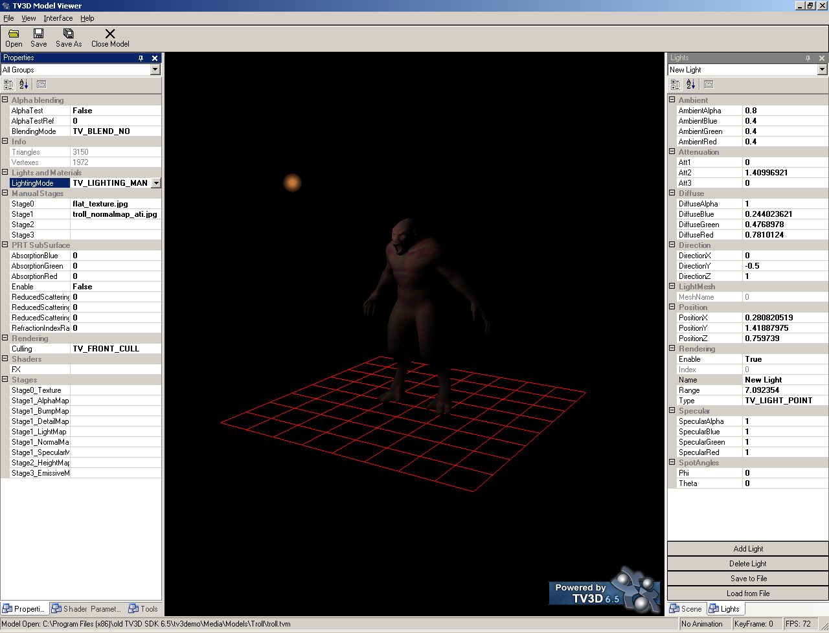
You can add more lights and play with the different light properties. If you click on the light you will select it, allowing you to drag it around the scene by pressing and holding Mouse Button 1. normalmapped models need to be rendered with the lighting mode TV_LIGHTING_BUMPMAPPING_TANGENTSPACE.
5. Model Properties and Shaders
When processing your models the left side area will be the most important one. On the left side you have model properties, shader parameters and Tools. Using these 3 tabs in the dock you can prepare your model for in game integration. Alpha blending, lights and materials, stages and shaders. Lets open up a model and apply a custom shader to it and modify some of the parameters for it.

Once you have your model open double click the FX parameter under “Shaders” in Model Properties. Browse for the shader “MrWiggle.fx”. It is located under your TV3D SDK 6.5\TV3Demo\Media\Shaders folder.

ModelView will automatically apply the shader to your model and set default parameters taken from the shader file (if any exist). You can modify these parameters in MV by going to the “Shader Parameters” tab under Model Properties dock. This is how it could look like when applying the MrWiggle.fx shader to a model (Note: Currently the shader is not saved back into the TVM/TVA format):

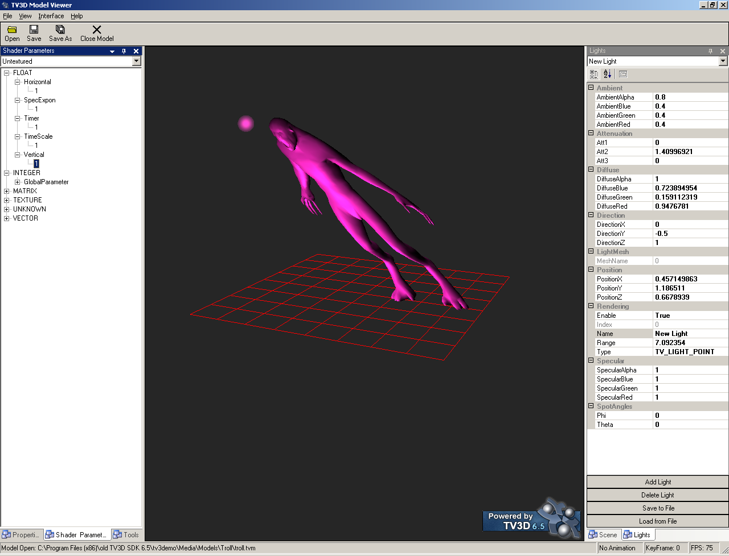
Using the Model Properties dock you can change many things, lighting modes, set texture stages, change actor modes and more. By working with these you can achieve the desired effect on your model. All of these properties are saved back into your TVM/TVA model (except the shader information, this will be added in the final release of 6.5).
6. Global, Mesh and Actor Tools
In the Tools tab on the left side you have several functions at your disposal. Global tools are applicable for Mesh and Actors. Mesh and actor tools are only applicable for respective format.

Flip Normalmap Tangent
Flips the normalmap tangents on the model. This is useful if you used a normalmap generated outside of MV and you notice some normalmap artifacts, bumps being holes or seams for example.

Flip Normalmap Binormal to DX
Flips the normalmap binormals to DirectX orientation. Try this if you notice seams and artifacts on normalmaps generated outside of MV.

Save Stage1 Texture
Useful if you want to, at any point, save the Stage1 texture to file.

Apply Default Material
Applies a default material to all groups of the model. This is very useful if your model has a weak material where you cannot clearly see how well the normalmap or lights affect it.

Compute Normals
Computes the normals of the model. It is a recommendation to always run this before generating any sort of normalmap.

Remove UV
Removes the models UV cordinates.

Weld Mesh
Welds the mesh, meaning it welds the vertexes together that share the same position.

Generate Normalmap
To generate a normalmap for your model you simply press this button. A new dialog will open that looks like this:

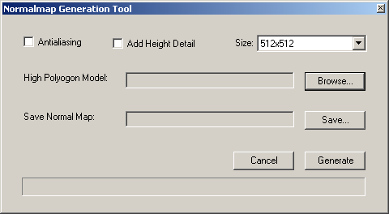
To generate a normalmap you must load a high polygon model of the model loaded in MV, choose a location to save your normalmap and press generate. You can change the attributes of the normalmap, such as enabling anti aliasing, adding height detail from the heightmap stage (which you can set in the Model Properties).

Generate PRT
Generates PRT data for the model. PRT stands for Precomputed Radiance Transfer and is a lighting technique that gives the model very realistic lighting. Once PRT data is computed you can add any amount of light to the scene without any big hits on the FPS. When you press this button a dialog that looks like this will open:

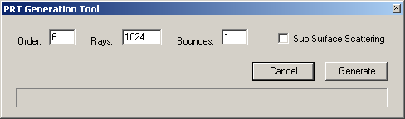
You can set the PRT parameters in this dialog box and when you are done press Generate to generate the PRT data. The model will automatically be set on PRT lighting and you can add lights to your scene to see the result. Saving the model back to TVM/TVA will save the PRT information inside of it, ready for ingame.

Animation Ranges
Using this tool you can define any number of animation ranges. This basically means you can chop up any of your animations and set an StartFrame and EndFrame and name that animation as a new one. This is saved back into the TVA when you save the model.

Control Morph Weight
If your model contains morph targets you can test these by setting their weight using this tool.

Add Morph Targets
You can add as many morph targets as you like using this tool. The model you are adding the poses to must be an actor model and the poses must be static poses of the same model, TVM or X format. The first pose that you load is a reference pose, a model that matches the animated model in its initial pose (no animation). Once this is added you can add as many poses as you like that differ from the reference pose, these will be your morph targets.

7. Notes and known Bugs
If you notice that some effects do not work as you expect them on your actor model try to change the actor mode around, usually the problem lies here. Note that currently the shader assignment and shader parameters are not saved back into the TVM/TVA model format. If you add a light to the scene and if it is randomly placed inside the models bounding box you might have a hard time to pick it with the mouse. Just delete the light and add a new one, or change the position of the light. If the model disappears from view when you change lighting mode its most probably because you do not have a normalmap set or any lights in the scene. Play with the ModelView until you get a grasp of it!

